Automating updates

# Why?

### Problem

The content update process - updating Blackboard using the Content Interface - can be a somewhat complex, off-putting process for some. Even when it [is semi-automated](https://djplaner.github.io/Content-Interface-Tweak/using/createAndModify/#semi-automated-three-step-process) it requires a number of less than obvious steps. Largely because Blackboard is difficult to integrate seamlessly into a workflow that draws on non-Blackboard software.

### Solution

The solution presented here is to automate the content update process using a [userscript](https://en.wikipedia.org/wiki/Userscript). The video below demonstrates what the automated content update process looks like.

Following the video is an explanation of how you automate the process by installing a [userscript](https://en.wikipedia.org/wiki/Userscript) into your Web browser. It is the userscript that reduces [the semi-automated three step process](https://djplaner.github.io/Content-Interface-Tweak/using/createAndModify/#semi-automated-three-step-process) into the single button press demonstrated in the video

<iframe width="560" height="315" src="https://www.youtube.com/embed/eJ_Ip6CUSDk?start=542" title="YouTube video player" frameborder="0" allow="accelerometer; autoplay; clipboard-write; encrypted-media; gyroscope; picture-in-picture" allowfullscreen></iframe>

# How to automate the process

To automate the process you will need to (explained in more detail below)

1. Install a [userscript manager](https://en.wikipedia.org/wiki/Userscript_manager) to your Web browser.
2. Install the Content Interface auto update userscript on the same Web browser.
3. Have a Content Document link on the Blackboard page you’re updating.

Note: The automated process will only work on Web browsers where you have completed these three steps.

If you have missed one of the first two steps, you will have to use [the semi-automated three step process](https://djplaner.github.io/Content-Interface-Tweak/using/createAndModify/#semi-automated-three-step-process).

If you have missed the last step, neither the automated or semi-automated steps will work.

The following video demonstrates the process for step 1 (installing Tampermonkey) and step 2 (installing the auto update userscript).

<iframe width="560" height="315" src="https://www.youtube.com/embed/eJ_Ip6CUSDk?start=301" title="YouTube video player" frameborder="0" allow="accelerometer; autoplay; clipboard-write; encrypted-media; gyroscope; picture-in-picture" allowfullscreen></iframe>

## 1. Install the Tampermonkey userscript manager

[Tampermonkey](https://www.tampermonkey.net/) is a widely used userscript manager. It can be used on most modern web browsers. The video at the end of this section introduces Tampermonkey and demonstrates how to install it on the Chrome web browser. The general installation process has three steps.

**i) Visit** [**the Tampermonkey home page**](https://www.tampermonkey.net/)**.**

You should something like   
Figure 1 in which the Firefox browser is being used. Hence the Firefox tab is active. The active tab should match the browser you are using.

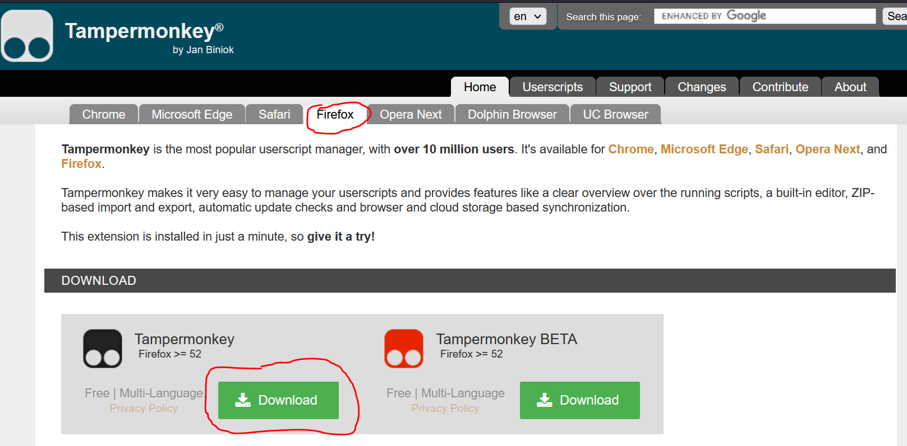  
Figure 1 - The Tampermonkey home page

**ii) Click on the left-hand *Download* button.**

You will be taken to your web browser’s [browser extension/add-ons](https://en.wikipedia.org/wiki/Browser_extension) store.

**iii) Follow the instructions to add Tampermonkey to your web browser.**

Each web browser’s [browser extension](https://en.wikipedia.org/wiki/Browser_extension) installation process will be a little different. In general, it will provide you with details of what permissions the browser extension (Tampemonkey in this case) wishes to have and provides you with the option to install.

<iframe width="560" height="315" src="https://www.youtube.com/embed/8tyjJD65zws" title="YouTube video player" frameborder="0" allow="accelerometer; autoplay; clipboard-write; encrypted-media; gyroscope; picture-in-picture" allowfullscreen></iframe>

## 2. Install the Content Interface auto update script

With the Tampermonkey userscript manager installed, you can

**i) Install the Content Interface auto update script**

Install [the Content Interface auto update script](https://github.com/djplaner/Content-Interface-Tweak/raw/master/userScripts/ciAutoUpdate.user.js) by clicking on that link. If all is working you should see Figure 2 showing Tampermonkey providing you with details of the userscript and asking if you wish to install it.

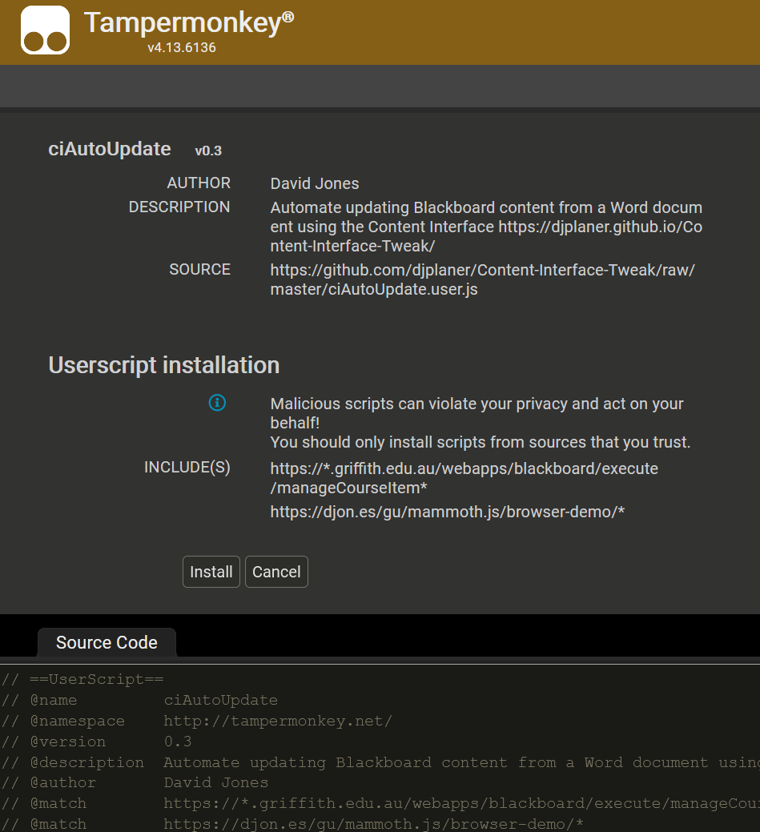Figure - Information about Content Interface userscript shown during installation

**ii) Click the *Install* button**

Clicking the *Install* button will add this userscript to Tampemonkey on your browser. You can view, configure, and remove instaled userscripts using the Tampemonkey dashboard, illustrated in Figure 3.

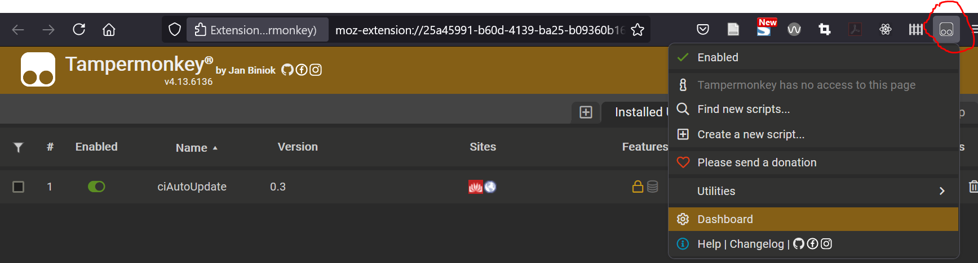Figure - Tampermonkey dashboard showing the Content Interface userscript

## 3. Have a *Content Document* link on the Blackboard page

The semi-automated and automated update processes only work with Blackboard pages that have three items:

1. A *Content Interface* [content item](https://utlv.screenstepslive.com/s/faculty/m/BlackboardLearn/l/185559-creating-a-content-item) (the name must match).  
   This is the content item into which the content from the Word document will be placed. Initially this content item will be empty.
2. A *Content Document* [web link](https://utlv.screenstepslive.com/s/faculty/m/BlackboardLearn/l/185566-creating-a-link-to-an-external-site-in-blackboard) (the name must match).  
   This is a web link to the Word document containing the content.
3. A *Content Management* content item (the name doesn’t have to match).  
   Contains the code that manages and displays the content.

Figure 4 is an example of a Blackboard page with these three items. The Content Interface code is working because you can see the *How to update the content* and other help information in the *Content Management* item.

You can check to see if the *Content Document* link is working for you by clicking on either the *Content Document* link or the *online* link (both circled in red in Figure 4). Clicking on both links should open in your Web browser the Word document containing the content you wish to place in Blackboad.

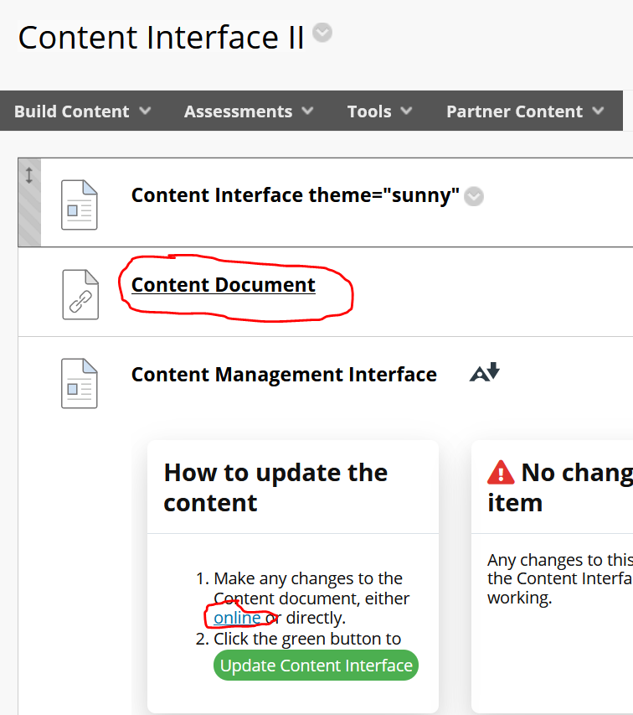Figure 4 - A Blackboard page with the three necessary items for (semi-)automated updates

**i) Share your Word document with O365**

The first step is to create an appropriately shared link (URL) to your Word document. This link allows you (and anyone you decide should be allowed e.g. your teaching team) to access the Word document via the Web.

To do this you will need to save your Word document to [OneDrive](https://staffhelp.secure.griffith.edu.au/app/answers/detail/a_id/3405/~/how-do-i-set-up-onedrive-for-business%3F) or SharePoint using Griffith University’s Office 365 services. This may already have been done for you.

You can then create an appropriately shared link using these instructions for either [OneDrive](https://support.microsoft.com/en-us/office/share-onedrive-files-and-folders-9fcc2f7d-de0c-4cec-93b0-a82024800c07) or [Word](https://support.microsoft.com/en-us/office/share-files-and-folders-with-microsoft-365-business-72f26d6c-bf9e-432c-8b96-e3c2437f5b65). Copy the shared link to your clipboard.

It is recommended that you use the *People with existing access* sharing option.

**ii) Create a Web Link item on the Blackboard page**

With the shared link to your Word document in your clipboard follow the instructions on [this page to create a web link item](https://utlv.screenstepslive.com/s/faculty/m/BlackboardLearn/l/185566-creating-a-link-to-an-external-site-in-blackboard) on the Blackboard page that points to your Word document.